Clean With Green

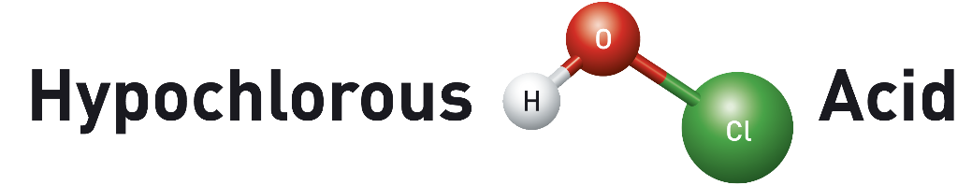

Created using electrolyzed water technology, Hypochlorous Acid (HOCl) is a safe, non-toxic, natural substance created in the white cells of the human body that when duplicated by scientists, has been used as a powerful disinfectant for more than a century.

The chemical ”opposite” of chlorine bleach, Hypochlorous Acid (HOCl) solutions are 100x MORE POWERFUL antimicrobials than bleach as well as most conventional or industrial cleaning products. Safe to touch, they’re more than just powerful disinfectants, they are also excellent as a hand sanitizer, and can also remove biofilms and grease like nothing else.

Unlike bleach or toxic cleaning chemicals, HOCl is safe on or around humans, pets, plants and even food. That means it can be introduced to any environment by liquid or airborne means; no other chemical, bleach or antibacterial can make that claim. You can disinfect an entire room in minutes, with or without the presence of humans or food sources.
This can be a BIG advantage to any public business.

- 100x MORE POWERFUL disinfectant than bleach, the gold standard of germ killing; an important distinction as we all try to emerge safely from quarantine
- Kills all known dangerous pathogens, viral and bacterial, on contact with lasting protection
- 100% SAFE non-toxic on or around humans, pets, plants and marine life
- Organic, non-corrosive, non-hazardous, all-natural; environmentally friendly
- EPA registered as a safe and powerful disinfectant
- Inexpensive, minimal storage space required (commercially available generators allow anyone to make it on site)
- Proven – used in hospitals and surgical suites for more than a century

Spend less time cleaning with safer, more sanitary results. Let your business COME BACK WITH CONFIDENCE that you have gone the extra mile in cleanliness to better protect your employees and customers or patients.

